IP ADRESSS

IP Address :

An IP (Internet Protocol) address is a unique numerical label assigned to each device connected to a computer network. It serves as an identifier, allowing devices to send and receive data by specifying the source and destination in every data packet.

Types of IP addresses :

IP addresses are classified in several ways, including by version, availability, and how they are assigned.

**By version**

IPv4 (Internet Protocol Version 4) :

This is the original and most common version of IP, using a 32-bit numbering system.

* Format: Four sets of numbers, from 0 to 255, separated by dots (e.g., 192.168.1.1).
* Capacity: Over 4.3 billion unique addresses.
* Status: Due to the explosive growth of connected devices, the supply of IPv4 addresses is nearly exhausted.

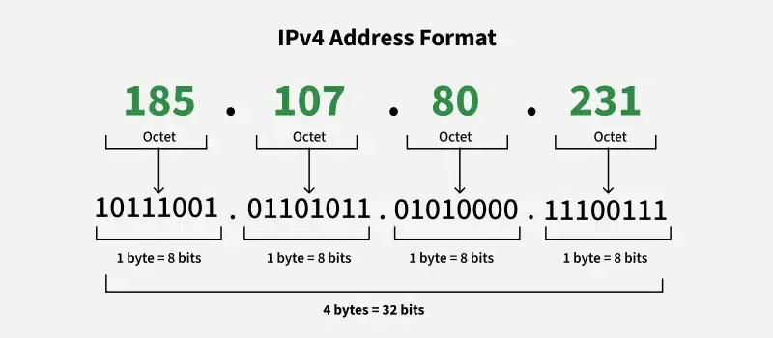

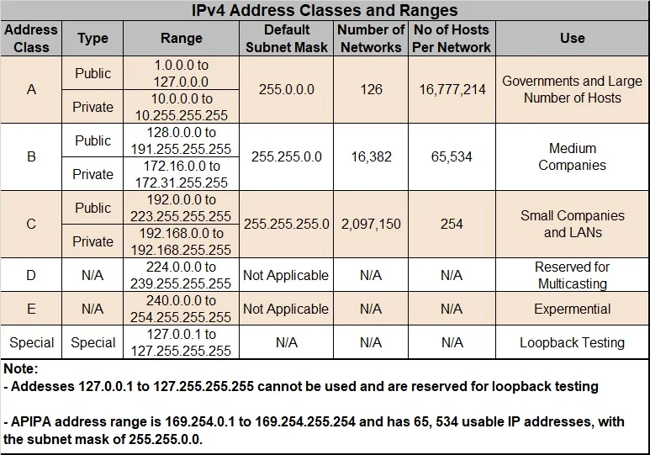

IPv6 (Internet Protocol Version 6) :

Developed to address the shortage of IPv4 addresses, IPv6 uses a 128-bit system.

* Format: Eight groups of four hexadecimal digits separated by colons (e.g., 2001:0db8:85a3:0000:0000:8a2e:0370:7334).
* Capacity: An astronomical number of unique addresses (approximately 340 undecillion), ensuring a virtually limitless supply.
* Status: Adoption is increasing as more devices and networks transition to the newer standard.

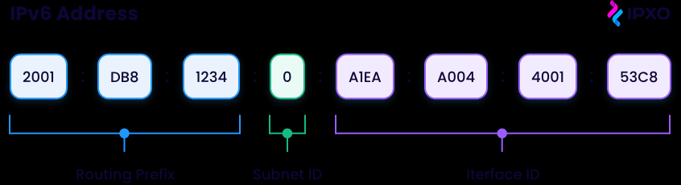

Routing Subnet Interface

Prefix ID ID

**By scope**

Public IP address

* A public IP address is a unique, external-facing address assigned to your network by your Internet Service Provider (ISP).
* It is visible to all other devices on the public internet.
* Your router uses this address to identify your network to the wider internet.
* All devices within your network use the same public IP address when communicating with the outside world.

Private IP address :

* A private IP address is an internal, non-routable address used within a local network, such as a home or office.
* It is used by your router to identify and communicate with devices on the local network.
* Devices like computers, phones, and printers each have a unique private IP within the local network.
* Specific ranges of addresses are reserved for private use, such as 192.168.x.x and 10.x.x.x.

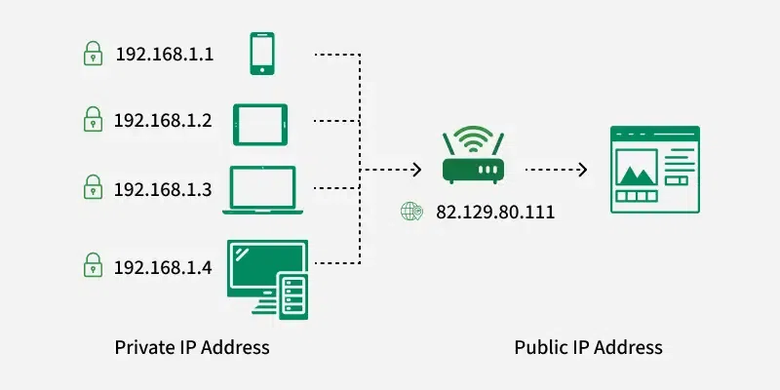

**By Assignment**

Dynamic IP address :

Dynamic IP addresses are the most common type for consumers and are automatically assigned by an ISP.

* Assignment: Managed by a DHCP (Dynamic Host Configuration Protocol) server.
* Lifespan: The address is temporary and can change whenever a device reconnects to the network, which enhances security by making tracking more difficult.
* Use case: Common for home networks and everyday internet usage.

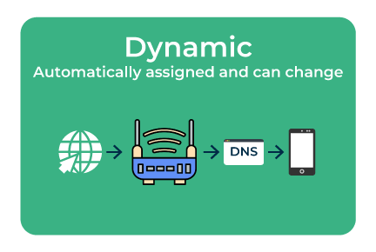

Static IP address :

A static IP address is a fixed, permanent address that does not change.

* Assignment: Manually configured by a network administrator.
* Lifespan: Remains the same indefinitely unless manually changed.
* Use case: Preferred for hosting websites, email servers, or other services that need a consistent, reachable address.

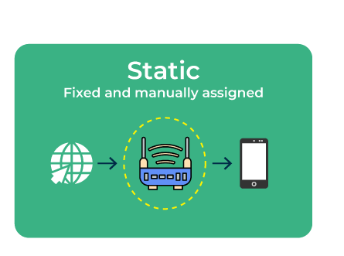

**By usage for websites**

Shared IP address

With a shared IP, multiple domains or websites on the same server share a single IP address.

* Cost: This is a cost-effective solution often used by hosting companies for small websites with low traffic.
* Disadvantage: If one website sharing the IP gets blacklisted, it could affect the reputation of other websites on that same IP.

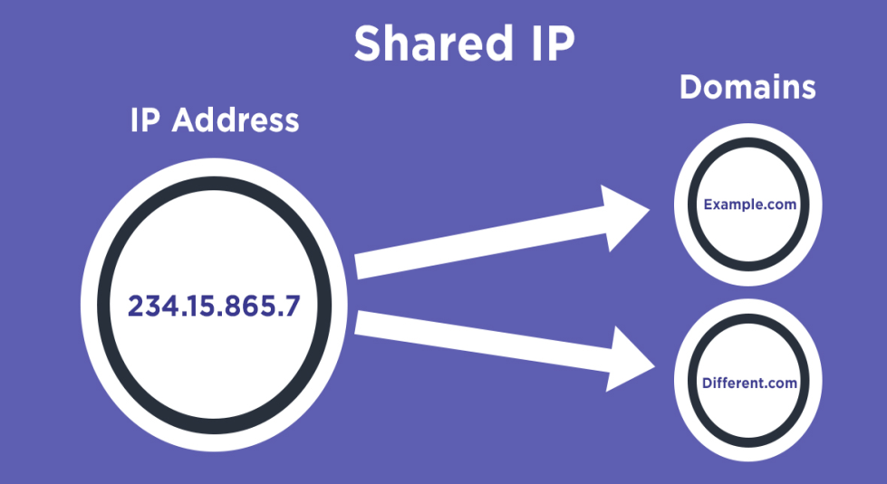

Dedicated IP address

A dedicated IP address is unique to a single website or domain.

* Cost: More expensive than a shared IP.
* Advantage: Offers increased security and can improve performance for high-traffic websites.

